**Program Book for**

**Community Service Project**

**Name of the Student: B. Sai Vamsi**

**Name of the College: ANNAMACHARYA INSTITUTE OF TECHNOLOGY AND SCIENCES, TIRUPATI**

**Registration Number: 23AK1A3094**

**Period of CSP:8 Weeks From: 02/06/2025 To: 25/07/2025**

**Name & Address of the Community/Habitation:**

Annamayya Nagar, Jeevakona, Tirupati

**Community Service Project Report**

*Submitted in accordance with the requirement for the degree of………….*

Name of the College: ANNAMACHARYA INSTITUTE OF TECHNOLOGY AND SCIENCES, TIRUPATI

Department: ARTIFICIAL INTELLIGENCE AND DATA SCIENCE

Name of the Faculty Guide: Mrs. Y. Kalaivani

Duration of the CSP: From 02/06/2025 To 25/07/2025

Name of the Student: B. Sai Vamsi

Programme of Study: AI & DS - B.Tech

Year of Study: II Year II Semester

Register Number: 23AK1A3094

Date of Submission:

# Student’s Declaration

I,…..............,a student of …….Program, Reg. No. ………………of the Department of……., ……………… College do hereby declare that I have completed the mandatory community service from…….. to in

………………. (Name of the Community/Habitation) under the Faculty Guideship of.................., (Name of the Faculty Guide), Department of………………in College

(Signature and Date)

# Endorsements

Faculty Guide

Head of the Department

Principal

**CHAPTER 1: EXECUTIVE SUMMARY**

*The community service report shall have only a one-page executive summary. It shall include a brief description of the Community and summary of all the activities done by the student in CSP and five or more learning objectives and outcomes.*

**CHAPTER 2: OVERVIEW OF THE COMMUNITY**

* *About the Community/Village/Habitation including historical profile of the community/habitation, community diversity, traditions, ethics and values.*
* 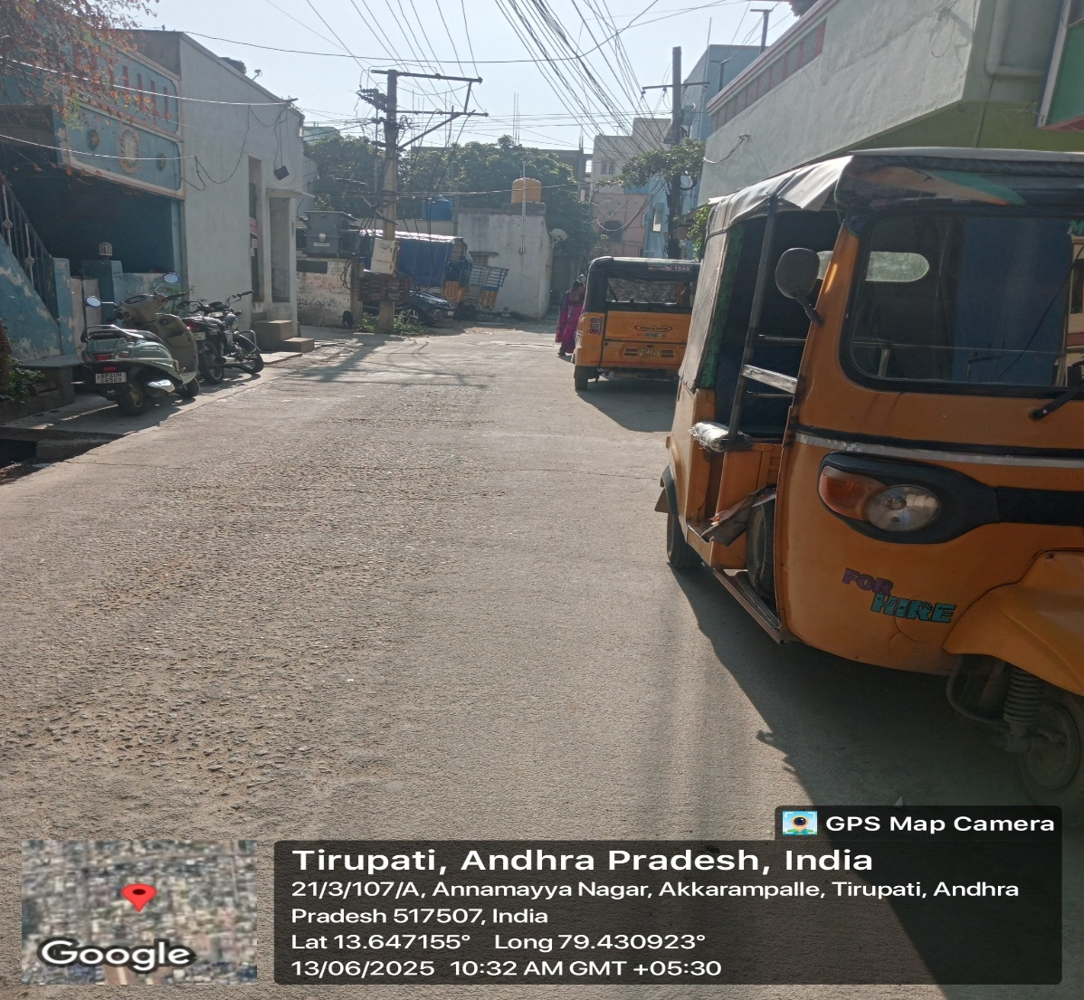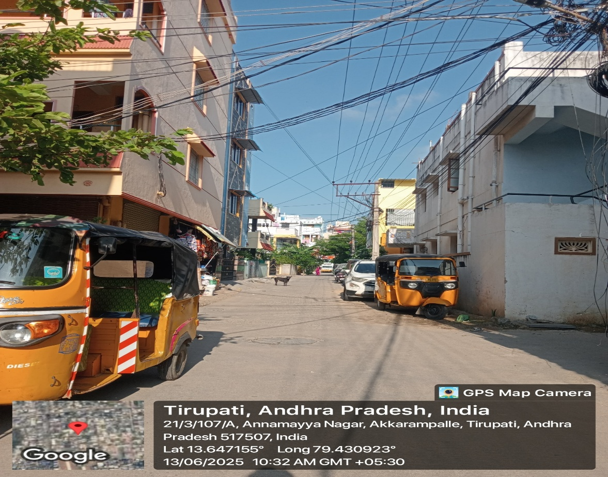*Brief note on Socio-Economic conditions of the Community/Habitation.*

**CHAPTER 3: COMMUNITY SERVICE PART**

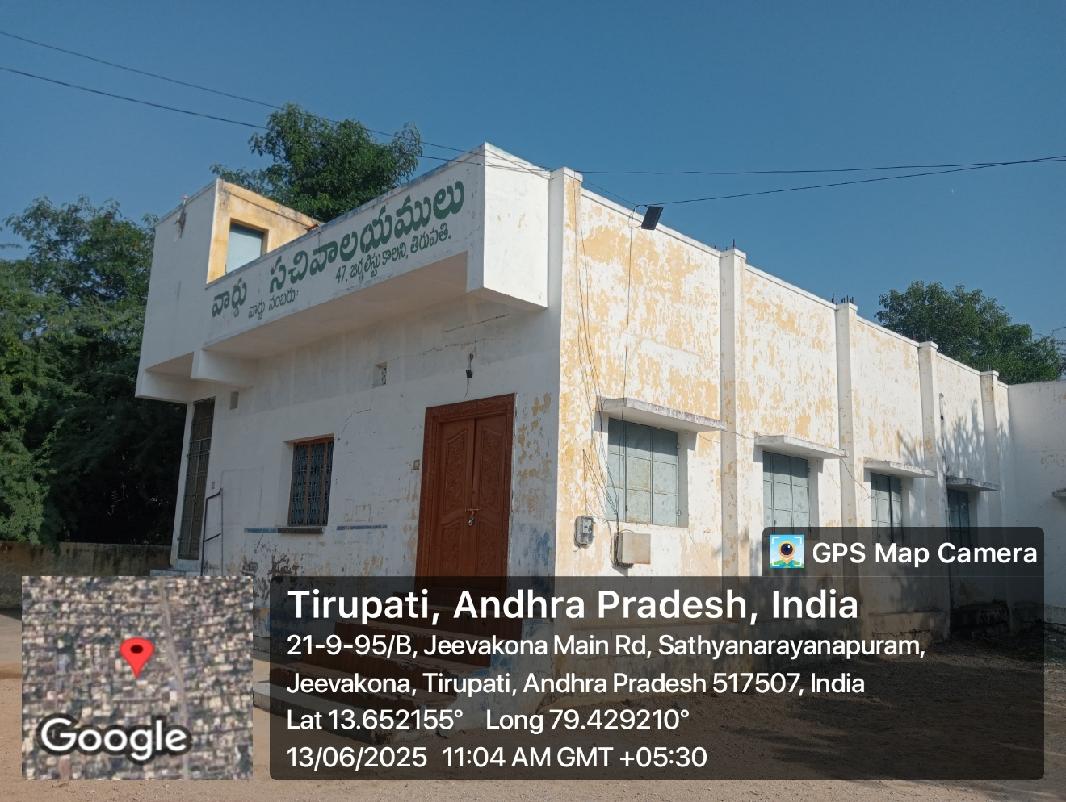*Description of the Activities undertaken in the Community during the Community Service Project. This part could end by reflecting on what kind of values, life skills, and technical skills the student acquired.*

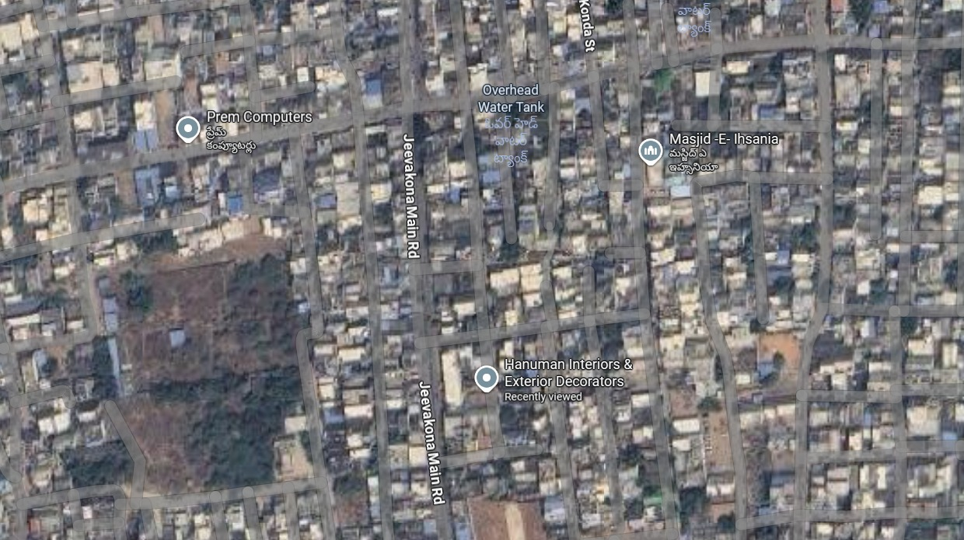

**CHAPTER 4: ACTIVITY LOG AND MILESTONE LOG REPORTS**

**ACTIVITY LOG FOR THE FIRST WEEK**

**Milestone Log Report For the 1st Week**

**WEEKLY REPORT**

**WEEK – 1 (From Dt………..….. to Dt…** **)**

|  |
| --- |
| **Objective of the Activity Done:** |
| **Detailed Report:** |
|  |
|  |
|  |
|  |
|  |
|  |
|  |
|  |
|  |
|  |
|  |
|  |
|  |
|  |
|  |
|  |
|  |
|  |

**CHAPTER 5: OUTCOMES DESCRIPTION**

**Details of the Socio-Economic Survey of the Village/Habitation. Attach the questionnaire prepared for the survey.**

|  |
| --- |
|  |
|  |
|  |
|  |
|  |
|  |
|  |
|  |
|  |
|  |
|  |
|  |
|  |
|  |
|  |
|  |
|  |
|  |
|  |
|  |
|  |

**Describe the problems you have identified in the community**

|  |
| --- |
|  |
|  |
|  |
|  |
|  |
|  |
|  |
|  |
|  |
|  |
|  |
|  |
|  |
|  |
|  |
|  |
|  |
|  |
|  |
|  |
|  |
|  |
|  |
|  |
|  |

**Short-term and long term action plan for possible solutions for the problems identified and that could be recommended to the concerned authorities for implementation.**

|  |
| --- |
|  |
|  |
|  |
|  |
|  |
|  |
|  |
|  |
|  |
|  |
|  |
|  |
|  |
|  |
|  |
|  |
|  |
|  |
|  |
|  |
|  |
|  |
|  |
|  |

**Description of the Community awareness programme/s conducted w.r.t the problems and their outcomes.**

|  |
| --- |
|  |
|  |
|  |
|  |
|  |
|  |
|  |
|  |
|  |
|  |
|  |
|  |
|  |
|  |
|  |
|  |
|  |
|  |
|  |
|  |
|  |
|  |
|  |
|  |
|  |

**Report of the mini-project work done in the related subject w.r.t the habitation/village.**

A mini-project work in the related subject w.r.t the habitation/village. (For ex., a student of Botany may do a project on Organic Farming or Horticulture or usage of biofertilizers or biopesticides or effect of the inorganic pesticides, etc. A student of Zoology may do a project on Aquaculture practices or animal husbandry or poultry or health and hygiene or Blood group analysis or survey on the Hypertension or survey on the prevalence of diabetes, etc.

The Report shall be limited to 6 pages.

**CHAPTER 6: RECOMMENDATIONS AND CONCLUSIONS OF THE MINI PROJECT**

**Student Self-Evaluation for the Community Service Project**

Student Name:

Registration No: Period of CSP: From:

To:

Date of Evaluation:

Name of the Person in-charge: Address with mobile number:

**Please rate your performance in the following areas:**

**Rating Scale: 1 is lowest and 5 is highest rank**

|  |  |  |  |  |  |
| --- | --- | --- | --- | --- | --- |
| **1) Oral communication** | **1** | **2** | **3** | **4** | **5** |
| **2) Written communication** | **1** | **2** | **3** | **4** | **5** |
| **3) Proactiveness** | **1** | **2** | **3** | **4** | **5** |
| **4) Interaction ability with community** | **1** | **2** | **3** | **4** | **5** |
| **5) Positive Attitude** | **1** | **2** | **3** | **4** | **5** |
| **6) Self-confidence** | **1** | **2** | **3** | **4** | **5** |
| **7) Ability to learn** | **1** | **2** | **3** | **4** | **5** |
| **8) Work Plan and organization** | **1** | **2** | **3** | **4** | **5** |
| **9) Professionalism** | **1** | **2** | **3** | **4** | **5** |
| **10) Creativity** | **1** | **2** | **3** | **4** | **5** |
| **11) Quality of work done** | **1** | **2** | **3** | **4** | **5** |
| **12) Time Management** | **1** | **2** | **3** | **4** | **5** |
| **13) Understanding the Community** | **1** | **2** | **3** | **4** | **5** |
| **14) Achievement of Desired Outcomes** | **1** | **2** | **3** | **4** | **5** |
| **15) OVERALL PERFORMANCE** | **1** | **2** | **3** | **4** | **5** |

**Date: Signature of the Student**

**Evaluation by the Person in-charge in the Community/Habitation**

Student Name: Registration No:

Period of CSP: From:

To:

Date of Evaluation:

Name of the Person in-charge: Address with mobile number:

**Please rate the student’s performance in the following areas:**

**Please note that your evaluation shall be done independent of the Student’s self-evaluation Rating Scale: 1 is lowest and 5 is highest rank**

|  |  |  |  |  |  |
| --- | --- | --- | --- | --- | --- |
| **1) Oral communication** | **1** | **2** | **3** | **4** | **5** |
| **2) Written communication** | **1** | **2** | **3** | **4** | **5** |
| **3) Proactiveness** | **1** | **2** | **3** | **4** | **5** |
| **4) Interaction ability with community** | **1** | **2** | **3** | **4** | **5** |
| **5) Positive Attitude** | **1** | **2** | **3** | **4** | **5** |
| **6) Self-confidence** | **1** | **2** | **3** | **4** | **5** |
| **7) Ability to learn** | **1** | **2** | **3** | **4** | **5** |
| **8) Work Plan and organization** | **1** | **2** | **3** | **4** | **5** |
| **9) Professionalism** | **1** | **2** | **3** | **4** | **5** |
| **10) Creativity** | **1** | **2** | **3** | **4** | **5** |
| **11) Quality of work done** | **1** | **2** | **3** | **4** | **5** |
| **12) Time Management** | **1** | **2** | **3** | **4** | **5** |
| **13) Understanding the Community** | **1** | **2** | **3** | **4** | **5** |
| **14) Achievement of Desired Outcomes** | **1** | **2** | **3** | **4** | **5** |
| **15) OVERALL PERFORMANCE** | **1** | **2** | **3** | **4** | **5** |

**Date: Signature of the Supervisor**

**PHOTOS AND VIDEO LINKS**

**(Note: Video in GOOGLE Drive link)**